Code of ATM Management System:

#include <iostream>
using namespace std;

const int MAX = 100;
void ShowMenu();
void CreateAccount(int& count, int accNo[], int pin[], double balance[]);
int Login(int count, int accNo[], int pin[]);
void CheckBalance(int index, double balance[]);
void Deposit(int index, double balance[]);
void Withdraw(int index, double balance[]);
void ExitATM(bool& running);

int main() {
int accNo[MAX];
int pin[MAX];
double balance[MAX];

int count = 0, choice;
bool running = true;

cout << "-------------------------------------"<<endl;
cout << " WELCOME TO ATM MACHINE "<<endl;
cout << "-------------------------------------"<<endl;

while (running) {
ShowMenu();
cin >> choice;

switch (choice) {
case 1:
CreateAccount(count, accNo, pin, balance);
break;

case 2: {
int index = Login(count, accNo, pin);
if (index != -1)
CheckBalance(index, balance);
break;
}

case 3: {
int index = Login(count, accNo, pin);
if (index != -1)
Deposit(index, balance);
break;
}

case 4: {
int index = Login(count, accNo, pin);
if (index != -1)
Withdraw(index, balance);
break;
}

case 5:
ExitATM(running);
break;

default:
cout << " Invalid choice! "<<endl;
}
}
return 0;
}
void ShowMenu() {
cout << " ATM MENU "<<endl;
cout << "1. Create Account"<<endl;
cout << "2. Check Balance"<<endl;
cout << "3. Deposit Money"<<endl;
cout << "4. Withdraw Money"<<endl;
cout << "5. Exit"<<endl;
cout << "Enter your choice: "<<endl;
}

void CreateAccount(int& count, int accNo[], int pin[], double balance[]) {
cout << "Enter Account Number: "<<endl;
cin >> accNo[count];

cout << "Set 4-digit PIN: "<<endl;
cin >> pin[count];

balance[count] = 0.0;
count++;

cout << "Account created successfully! "<<endl;
}

int Login(int count, int accNo[], int pin[]) {
int a, p;
cout << "Enter Account Number: "<<endl;
cin >> a;
cout << "Enter PIN: "<<endl;
cin >> p;

for (int i = 0; i < count; i++) {
if (accNo[i] == a && pin[i] == p) {
cout << "Login successful! "<<endl;
return i;
}
}
cout << "Wrong Account Number or PIN! "<<endl;
return -1;
}

void CheckBalance(int index, double balance[]) {
cout << "Your Balance: $" << balance[index]<<endl;
}

void Deposit(int index, double balance[]) {
double amount;
cout << "Enter deposit amount: "<<endl;
cin >> amount;

if (amount > 0) {
balance[index] =balance[index] + amount;
cout << "Deposit successful! "<<endl;
} else {
cout << "Invalid amount! "<<endl;
}
}

void Withdraw(int index, double balance[]) {
double amount;
cout << "Enter withdrawal amount: "<<endl;
cin >> amount;

if (amount > 0 && amount <= balance[index]) {
balance[index] =balance[index] - amount;
cout << "Please collect your cash. "<<endl;
} else {
cout << "Insufficient balance! "<<endl;
}
}

void ExitATM(bool& running) {
running = false;
cout << "Thank you for using ATM Machine! "<<endl;
}
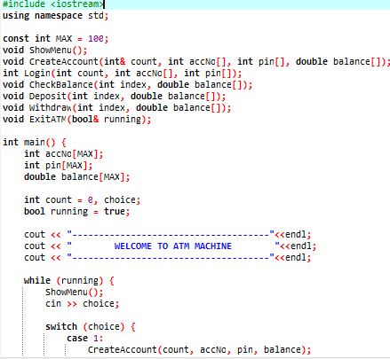
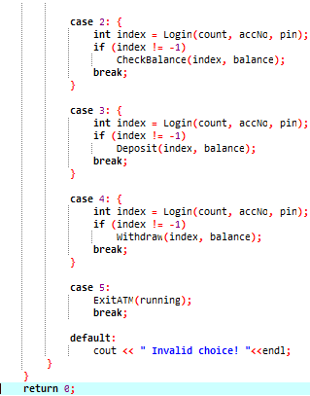
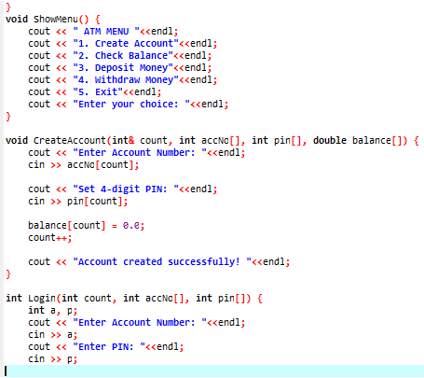
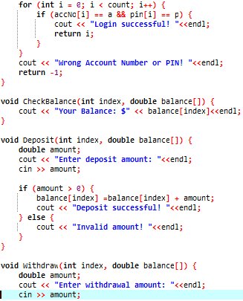
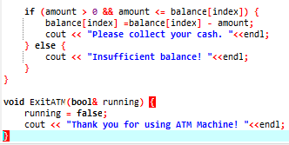

OUTPUT:
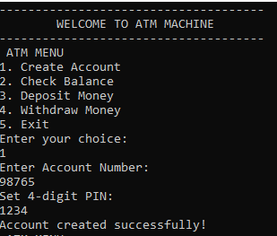
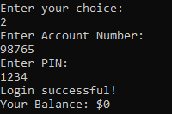
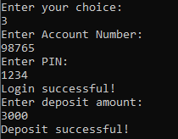
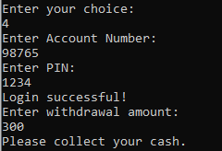
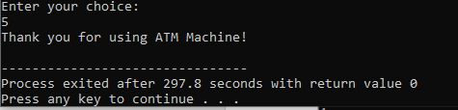

- Introduction

- This project is a console-based ATM system developed using C++.

- Which simulates basic ATM functionalities such as account creation, login authentication, balance inquiry, deposit, and withdrawal.

- The project gives a basic idea of how an ATM system works in real life by performing common banking tasks in a simple and interactive way.

- Objectives of the Project

- To understand functions and arrays in C++.
- To implement user authentication.
- To simulate real-world ATM operations.
- To practice menu-driven programming.
- To enhance logical and problem-solving skills.

- Tools & Technologies Used

- Programming Language: C++
- Compiler: Dev C++
- Platform: Console-based application

- System Overview

The ATM system stores:
- Account Numbers
- PIN Numbers
- Account Balance

- Features of the ATM System

- Create new bank accounts
- Secure login using account number and PIN
- Check account balance
- Deposit money
- Withdraw money
- Exit system safely

- Program Structure

The program uses:
- Arrays to store account data
- Functions to perform ATM operations
- Looping for continuous menu display
- Conditional statements for validation

- Menu Options

- Create Account
- Check Balance
- Deposit Money
- Withdraw Money
- Exit

- Function Description

  - ShowMenu()

Displays the ATM menu options to the user.

  - CreateAccount()

- Takes account number and PIN from user
- Initializes balance to zero
- Stores details in arrays

  - Login()

- Verifies account number and PIN
- Returns index of the user if login is successful

  - CheckBalance()

- Displays the current balance of the logged-in user

  - Deposit()

- Adds entered amount to the account balance
- Validates positive deposit amount

  - Withdraw()

- Deducts amount if sufficient balance is available
- Prevents overdraft

  - ExitATM()

- Safely exits the program
- Displays exit message

- Flow of ATM Operation

- User selects an option from the menu
- System asks for login details (except account creation)
- Authentication is performed
- Selected operation is executed
- Menu is displayed again until exit

- Advantages

- Simple and user-friendly
- Secure login system
- Easy to understand code structure
- Good learning project for beginners

- Limitations

- No file handling (data not saved permanently)
- PIN is not encrypted
- No account deletion feature
- Console-based interface only

Conclusion

This ATM Machine project successfully demonstrates how basic banking operations can be implemented using C++. It provides a strong foundation for understanding real-world ATM systems and can be enhanced further with advanced features.

